Q1. New Franchise Rollout
CineVault is opening a new Employee Performance tracking module, separate from the existing staff table.
- Create a table cv_employee_perf with: perf_id (INT, PK, AUTO_INCREMENT), staff_id (INT), review_month (DATE), films_processed (INT), rating (DECIMAL(3,1)), remarks (VARCHAR(255)).
Query:
CREATE TABLE cv_employee_perf (
perf_id INT PRIMARY KEY AUTO_INCREMENT,
staff_id INT,
review_month DATE,
films_processed INT,
rating DECIMAL(3,1),
remarks VARCHAR(255)
);
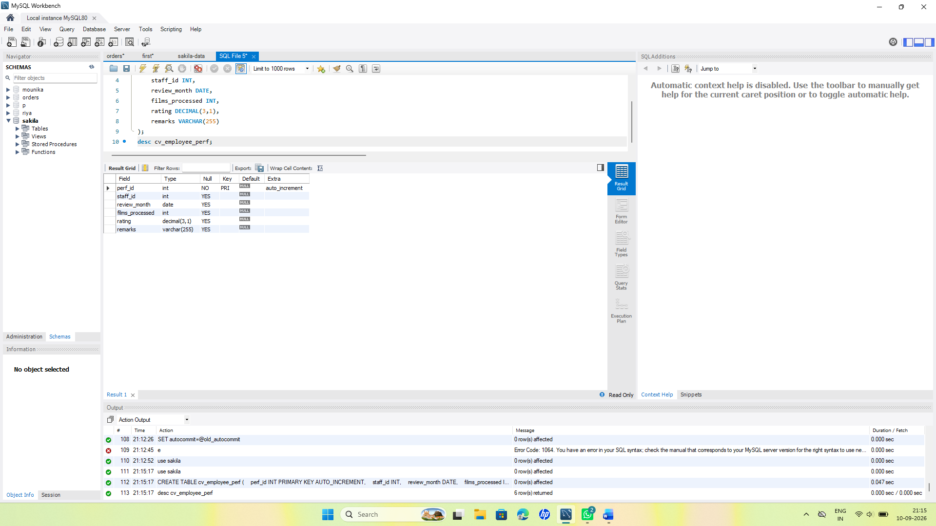
b) Add a FOREIGN KEY on staff_id referencing staff(staff_id).
Query:
ALTER TABLE cv_employee_perf MODIFY COLUMN staff_id TINYINT UNSIGNED;
ALTER TABLE cv_employee_perf
ADD CONSTRAINT fk_cv_employee_perf_staff
FOREIGN KEY (staff_id)REFERENCES staff (staff_id);
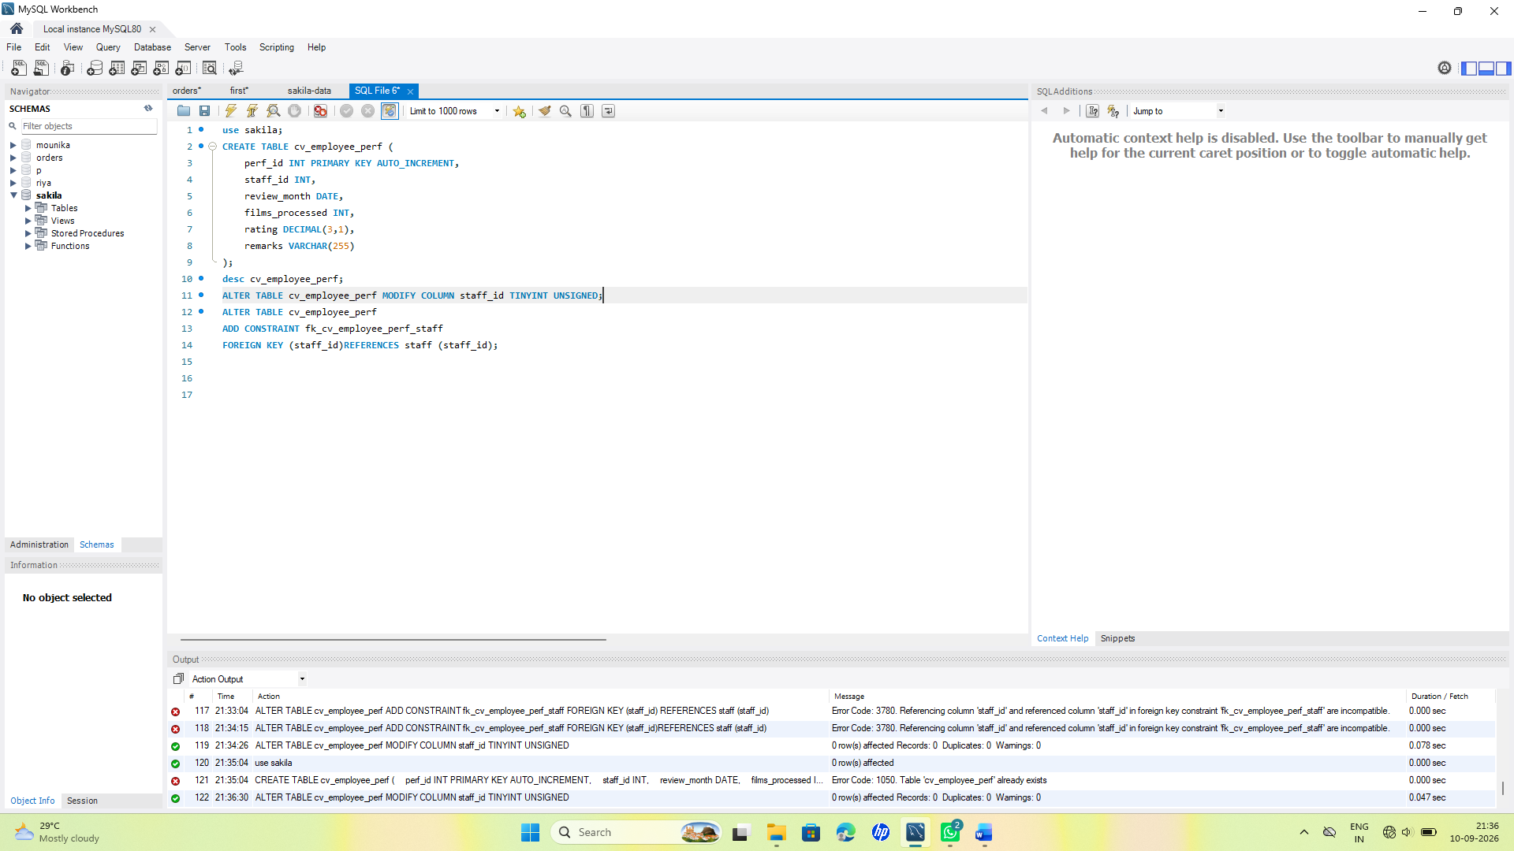c) Management realizes rating should never be NULL and should default to 3.0. Alter the table accordingly.
Query:
ALTER TABLE cv_employee_perf
MODIFY rating DECIMAL(3,1) NOT NULL DEFAULT 3.0;
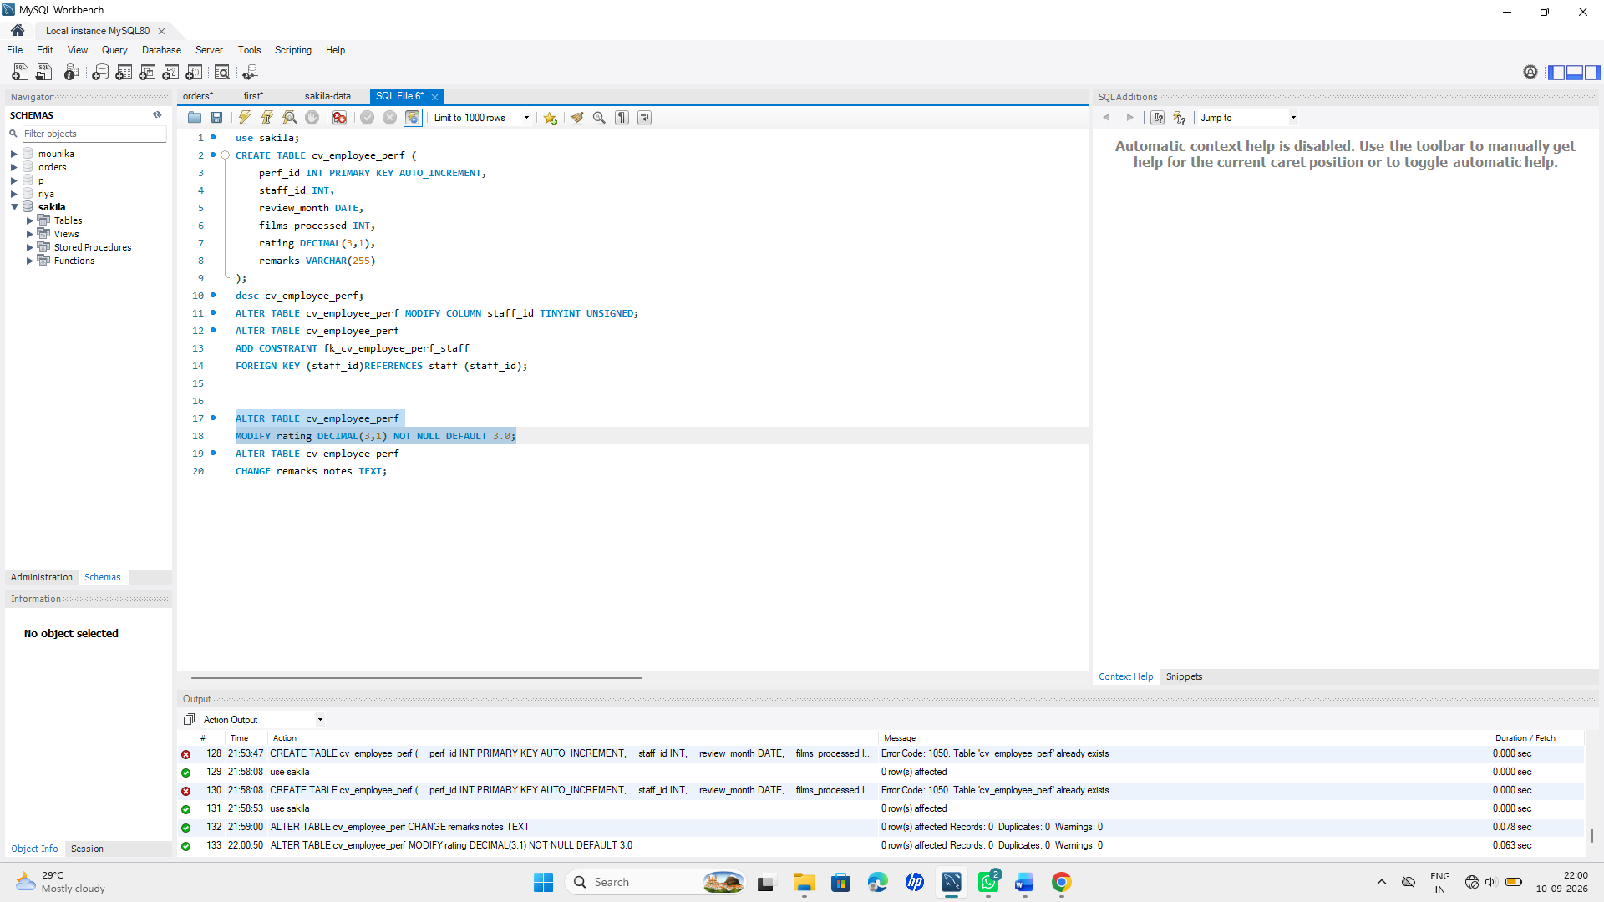
d) The remarks column is rarely used and wastes space in this design — rename it to notes and change its data type to TEXT in the same statement (or two, if your MySQL version needs it).
Query:
ALTER TABLE cv_employee_perf
CHANGE remarks notes TEXT;
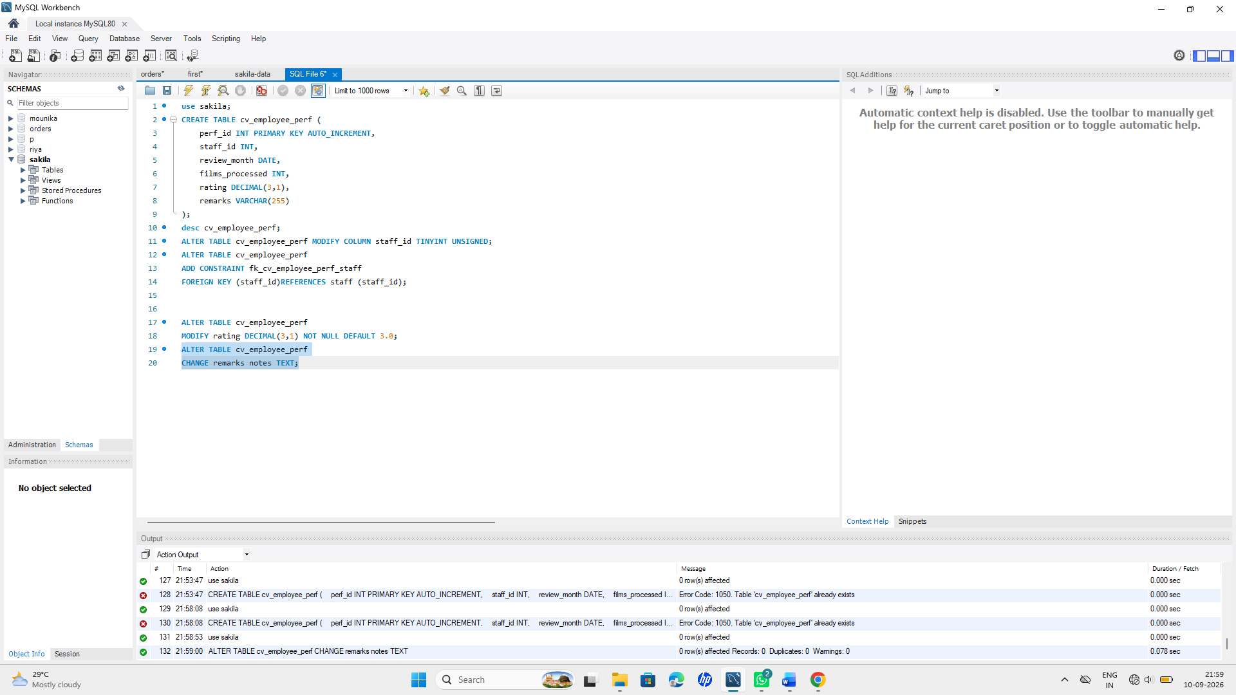
Q2. Data Type Conversion Issue
Finance reports that the rental_rate in the film table (currently DECIMAL(4,2)) is too restrictive for a new premium pricing tier going up to 999.99.
- Write the ALTER TABLE statement to widen rental_rate to DECIMAL(6,2) without losing existing data.
Query:
ALTER TABLE film
MODIFY rental_rate DECIMAL(6,2);
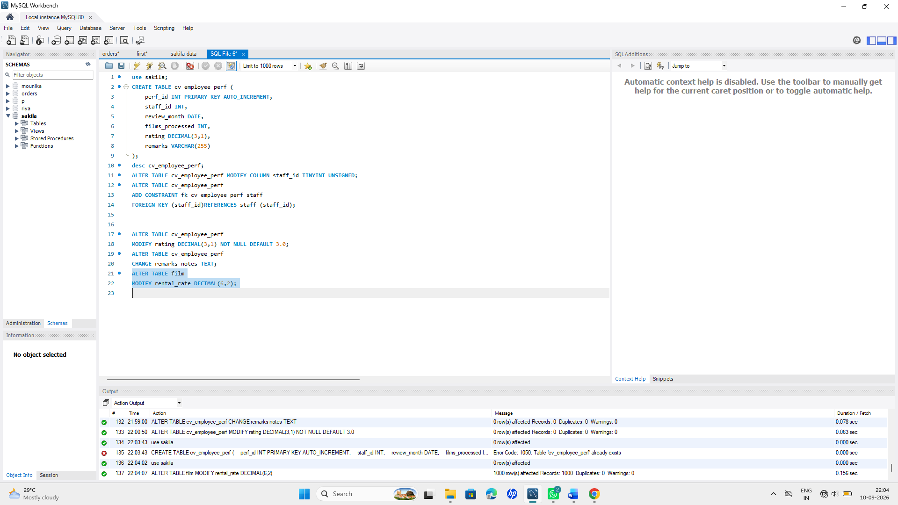
b) Write a query to convert and display the payment_date (DATETIME) from the payment table as just a DATE value (no time component) using a conversion function — do not alter the actual table.
Query:

SELECT
payment_id,
DATE(payment_date) AS payment_date
FROM payment;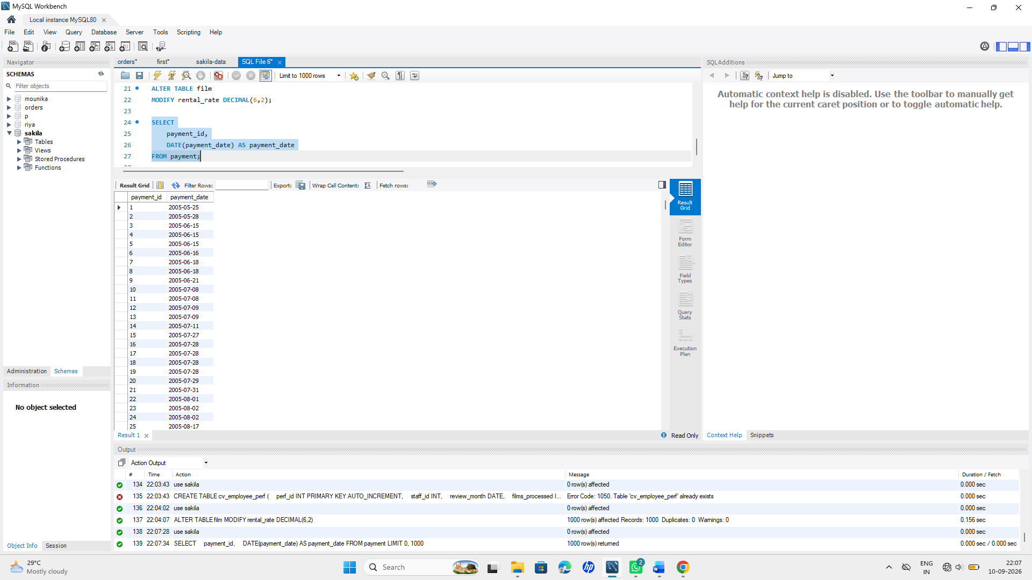
Q3. Decommissioning & Cleanup
The company is discontinuing the cv_employee_perf pilot after testing.
- Write a query to remove all rows from cv_employee_perf but keep the table structure intact for future use.
Query:
TRUNCATE TABLE cv_employee_perf;
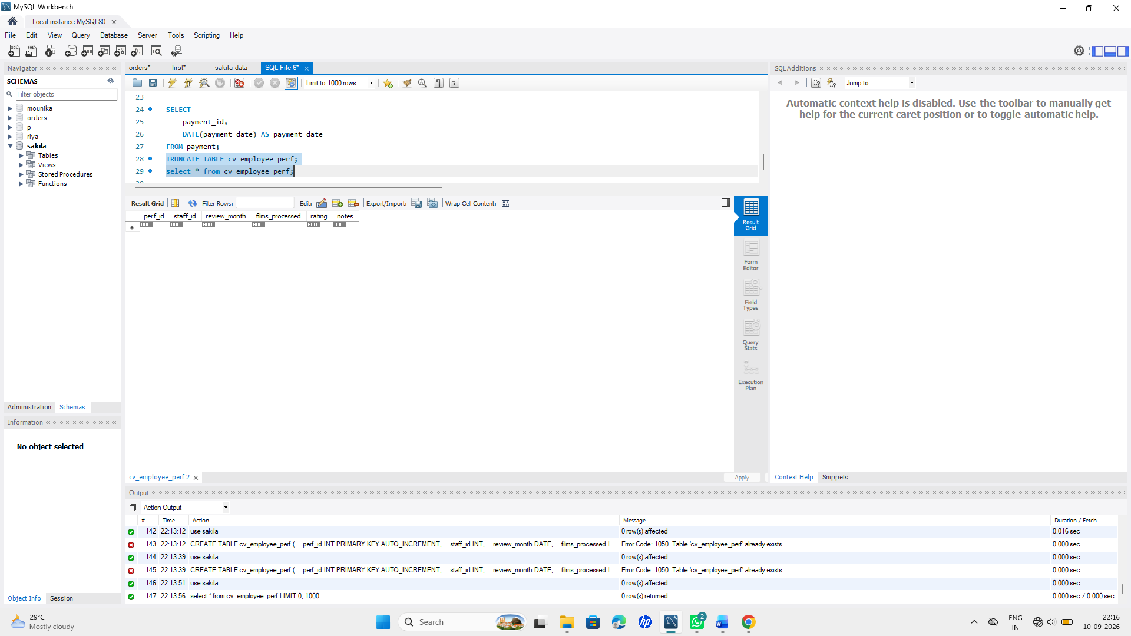

- Six months later, management confirms the module is cancelled permanently. Write the query to remove the table entirely.
Query:

DROP TABLE cv_employee_perf;
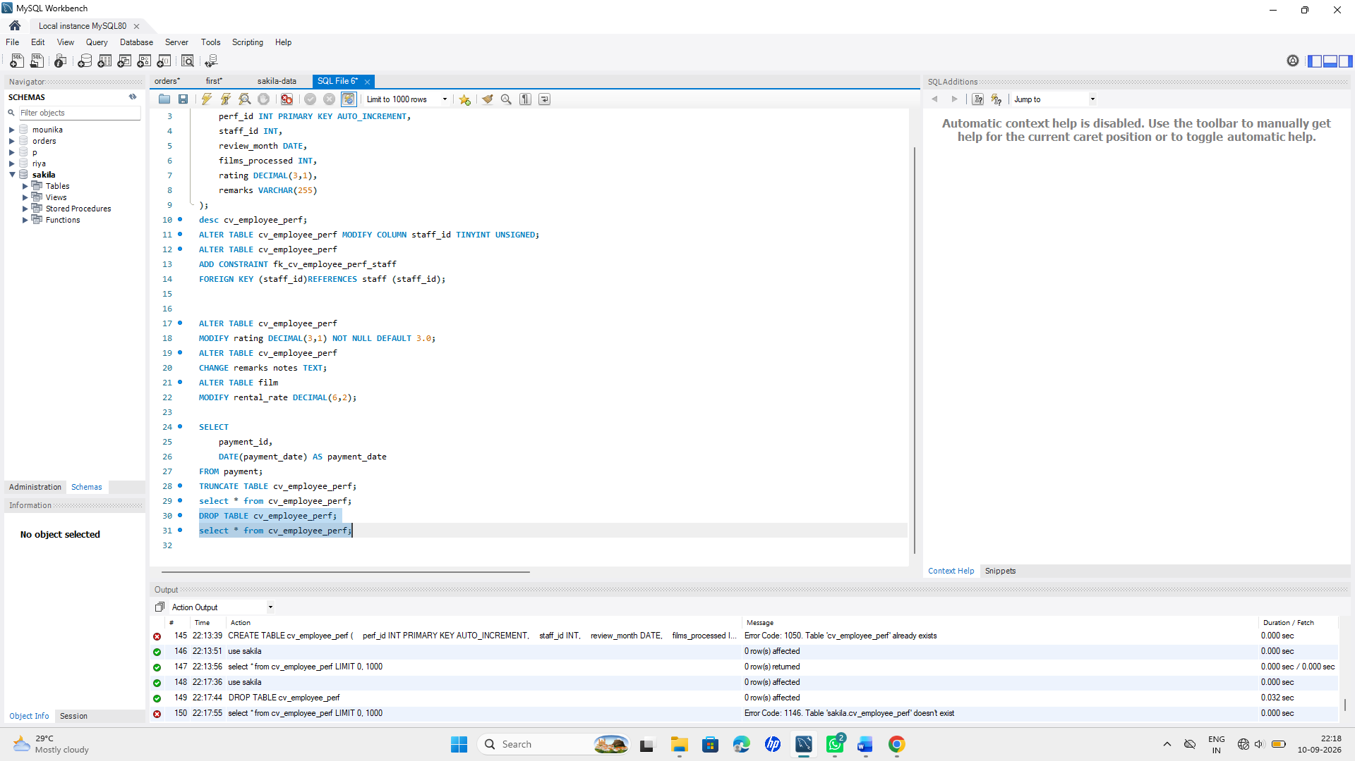

- In 2–3 lines, explain why you'd choose TRUNCATE for (a) and DROP for (b) instead of using DELETE for both.
Query:

**TRUNCATE is used in (a) because it removes all rows but keeps the table structure for future use.
***DROP is used in (b) because the module is permanently cancelled, so the entire table is no longer needed.
****DELETE is mainly used when we want to remove specific rows or apply a condition.
Q4. Normalization Check (Conceptual + Applied)
A new intern proposes storing customer_name, customer_email, film_title, and rental_date all in one flat table called rental_log_flat for “simplicity.”
- Identify which Normal Form this design violates and explain briefly (2–3 lines) why storing repeating customer/film details in every rental row is a problem.
This design violates 3NF (Third Normal Form). Storing customer and film details repeatedly in every rental row causes data redundancy and can lead to update, insert, and delete anomalies.This design violates 3NF (Third Normal Form). Storing customer and film details repeatedly in every rental row causes data redundancy and can lead to update, insert, and delete anomalies.
- Using the existing Sakila schema (customer, film, rental, inventory) as your reference, briefly explain (2–3 lines) how Sakila already avoids this problem — name the tables/keys involved.

Sakila avoids this problem by storing customer details in the customer table and film details in the film table. The rental table uses customer_id and inventory_id as foreign keys, while inventory connects the rental to the film using film_id.
Q5. Onboarding New Staff
Operations hired a new store employee. Insert a new row into staff for a person of your choice, ensuring you don't break any NOT NULL or FOREIGN KEY constraints (check the table structure first). List the columns explicitly in your INSERT statement.
check table structure:
DESCRIBE staff;
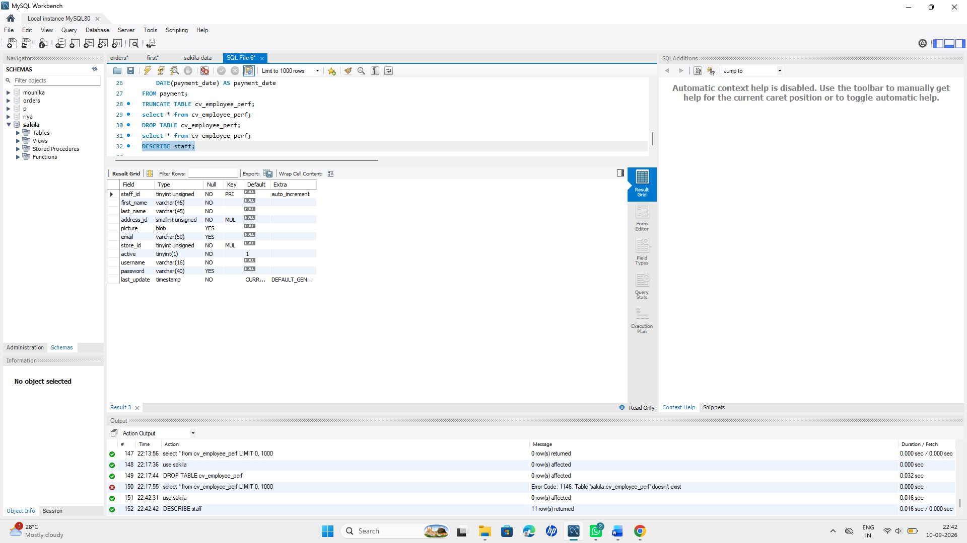
Then;
hired a new store employee:
Query:
INSERT INTO staff (first_name, last_name, address_id, email, store_id, active, username, password)
VALUES ('Mounika', 'Parasa', 1, 'mounika@example.com', 1, 1, 'mounika', 'Mounika@123');
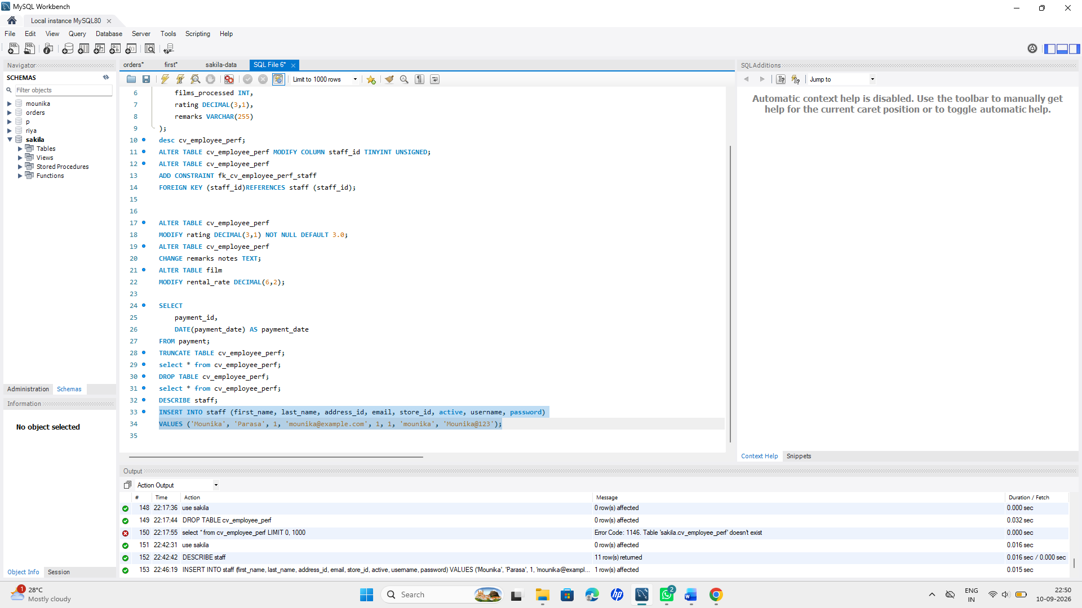
Q6. Price Correction — Bulk Update
Finance discovered that all films with rating = 'PG' were under-priced during a system migration.
- Write an UPDATE query to increase the rental_rate of all 'PG' rated films by 15%, rounded to 2 decimal places.
Query:
SET SQL_SAFE_UPDATES=0;
UPDATE film
SET rental_rate = ROUND(rental_rate * 1.15, 2)
WHERE rating = 'PG';
**To show output of increament of rental_rate:
*******SELECT film_id, title, rating, rental_rate
FROM film
WHERE rating = 'PG';
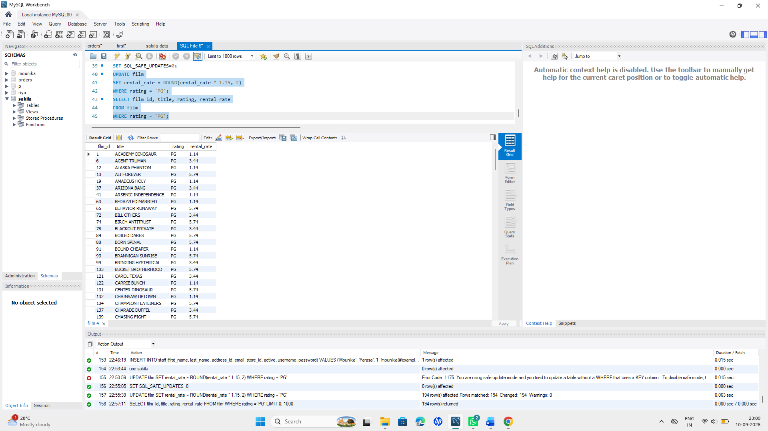
- Finance now wants to cap the replacement_cost at 25.00 for any film currently priced above that — write the query.
Query:
SET SQL_SAFE_UPDATES=0;
UPDATE film
SET replacement_cost = 25.00
WHERE replacement_cost > 25.00;
SELECT film_id, title, replacement_cost
FROM film
WHERE replacement_cost = 25.00;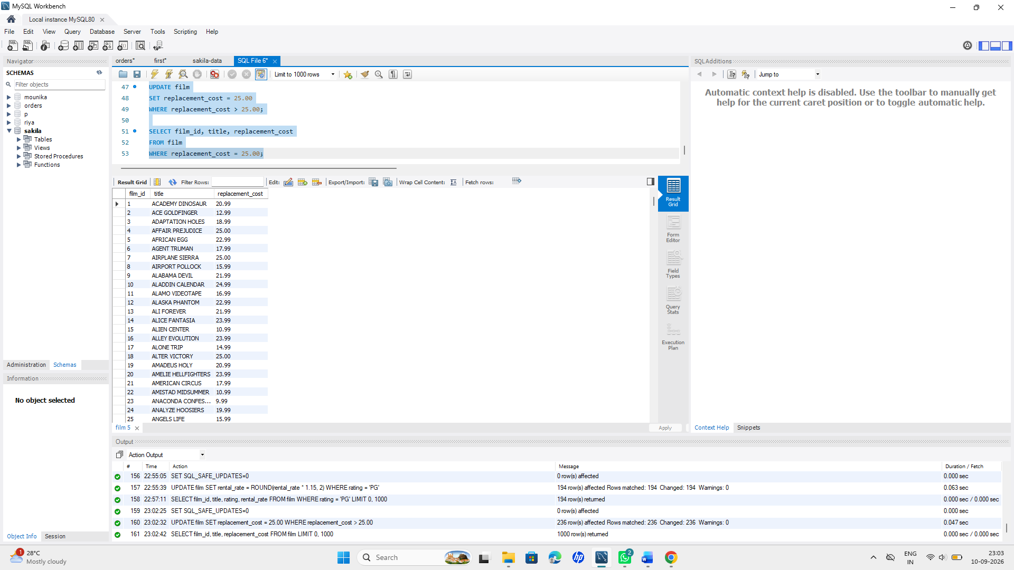
Q7. Data Cleanup — Conditional Delete
Operations wants to purge test/junk data.
- Write a query to delete rows from cv_employee_perf where films_processed = 0 and rating < 2.0.
Query :

DELETE FROM cv_employee_perf
WHERE films_processed = 0
AND rating < 2.0;
Above we drop the table cv_employee_perf.

- Explain (1–2 lines) what safeguard you should apply before running a DELETE without a WHERE clause in production.

*Before running a DELETE without a WHERE clause, take a backup of the data and verify the query carefully. Use a transaction so the changes can be rolled back if needed.

Q8. Marketing Segment 1 — Multi-condition Filter
Marketing wants a list of customers to target for a loyalty campaign: active customers (active = 1) who live in a district that is either 'California' or 'Texas', and whose customer_id is between 1 and 200. Write a single query using AND, OR, BETWEEN, and IN appropriately (use address/customer join).
Query:
SELECT c.customer_id, c.first_name, c.last_name, a.district
FROM customer c
JOIN address a
ON c.address_id = a.address_id
WHERE c.active = 1
AND a.district IN ('California', 'Texas')
AND c.customer_id BETWEEN 1 AND 200;

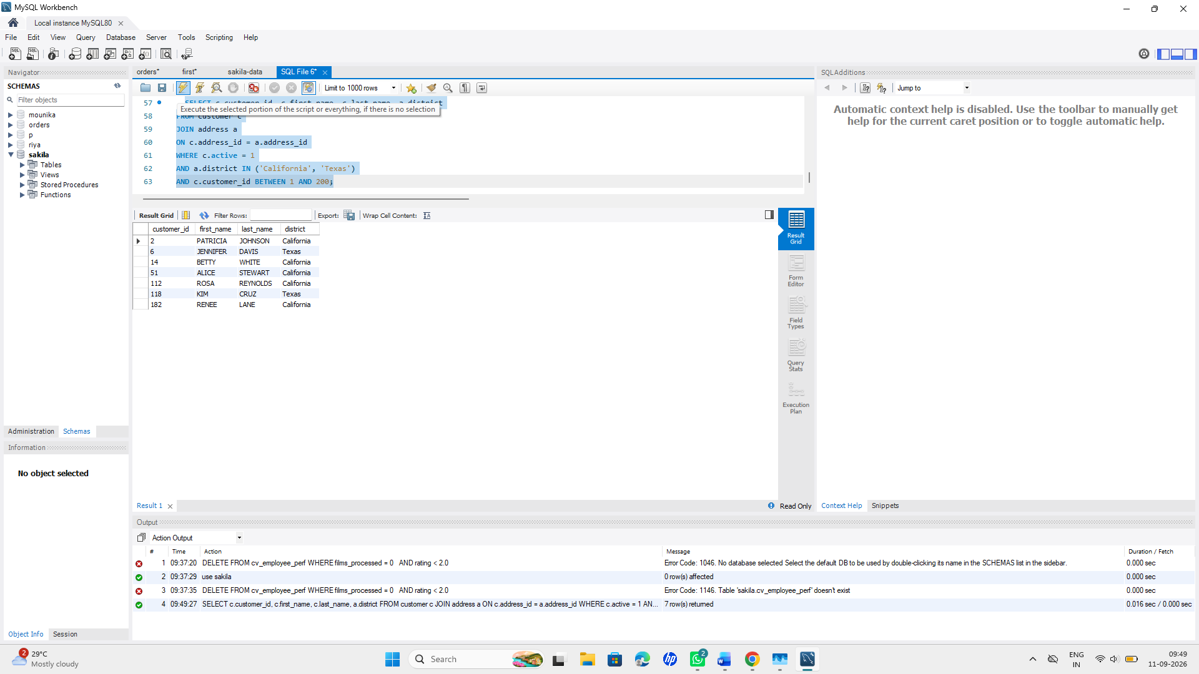

Q9. Marketing Segment 2 — Pattern & NULL Handling
- Write a query to find all customers whose email contains 'sakilacustomer.org' (use LIKE).
Query:

SELECT *
FROM customer
WHERE email LIKE '%sakilacustomer.org%';

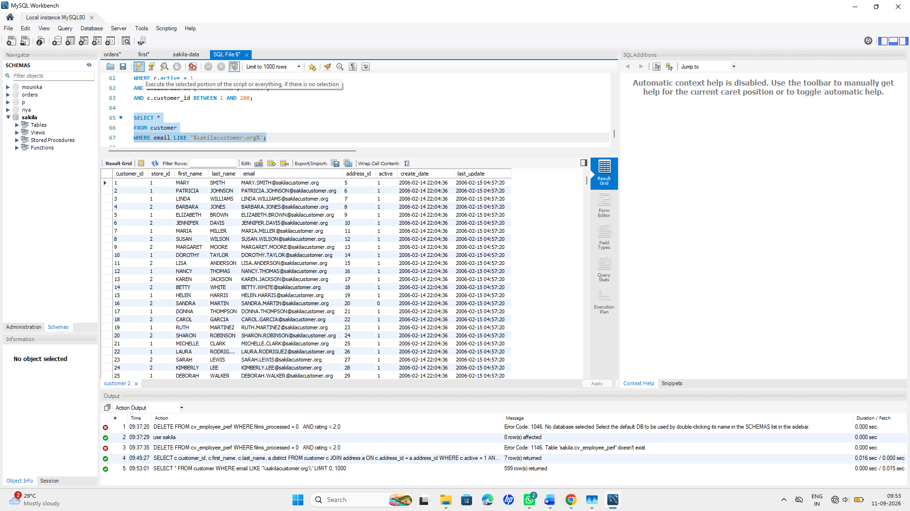

- Write a query to find all films where the description does not contain the word 'Amazing'.
Query:

SELECT *
FROM film
WHERE description NOT LIKE '%Amazing%';
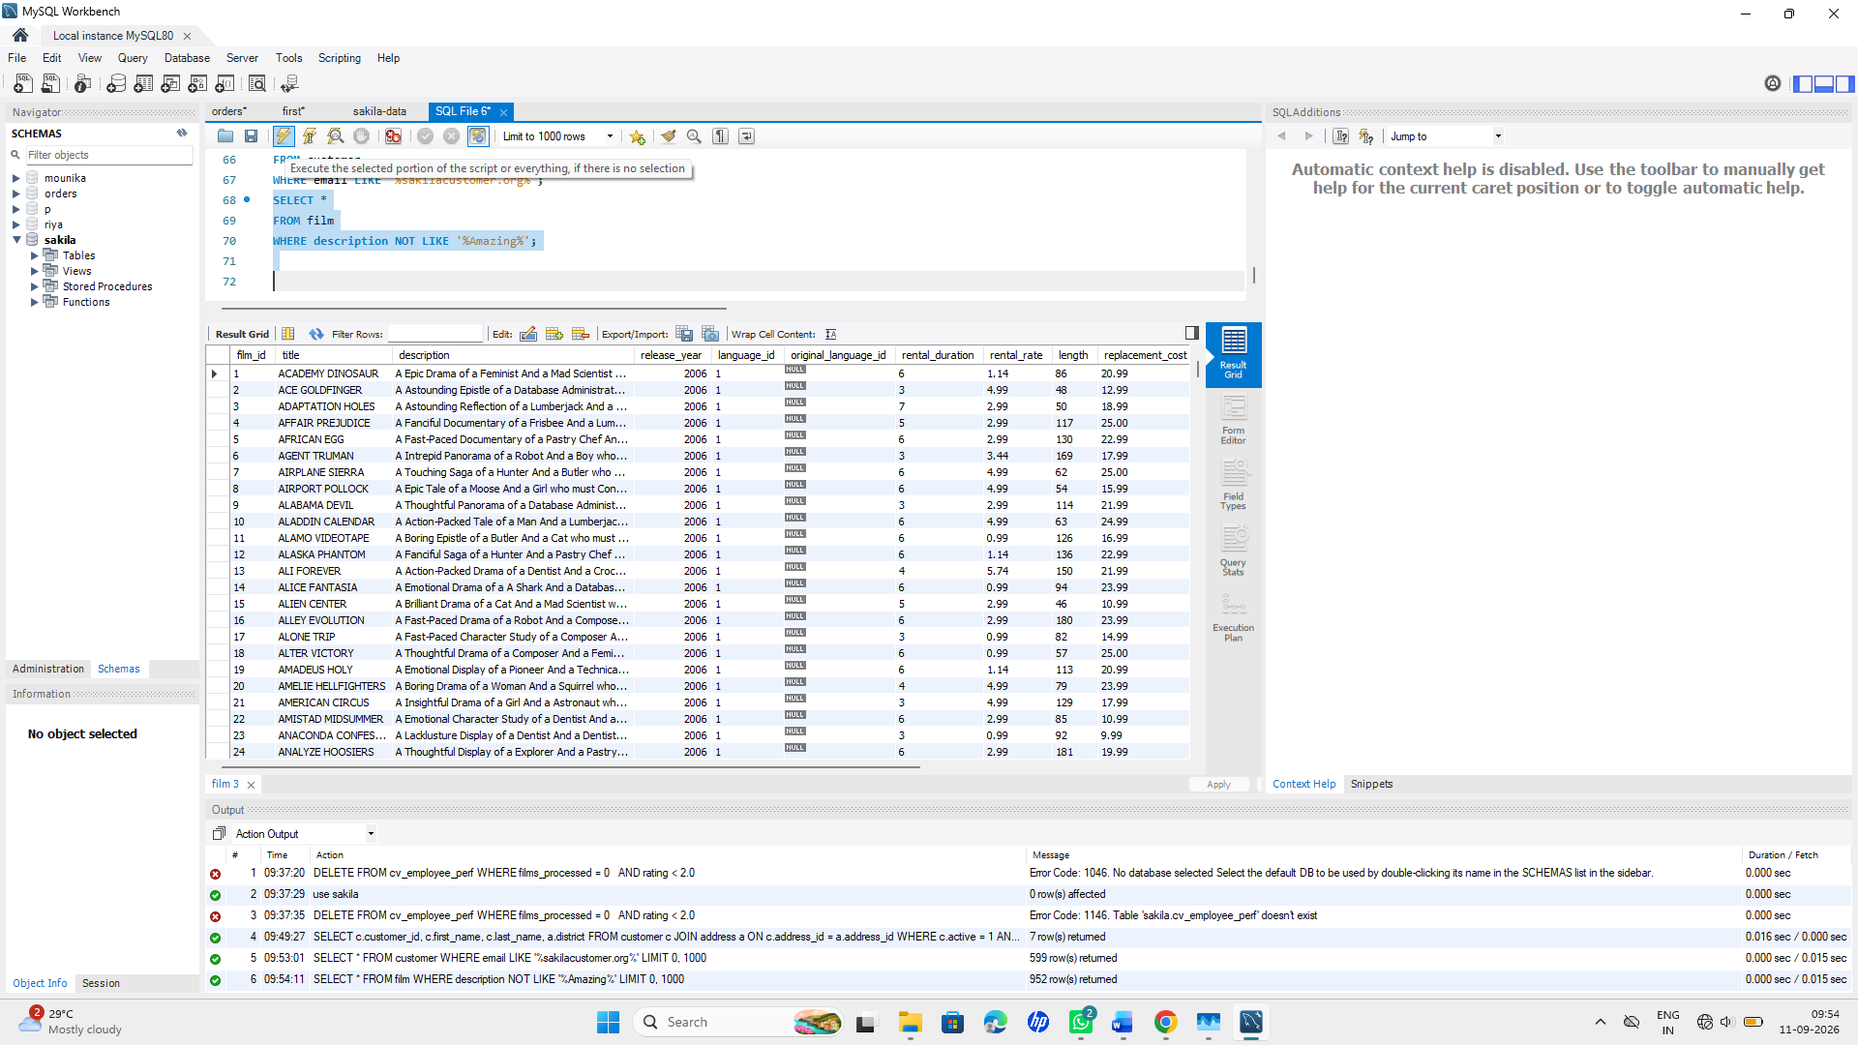

- Write a query to list all rentals from the rental table where return_date IS NULL (i.e., currently rented out / overdue).
Query:

SELECT *
FROM rental
WHERE return_date IS NULL;
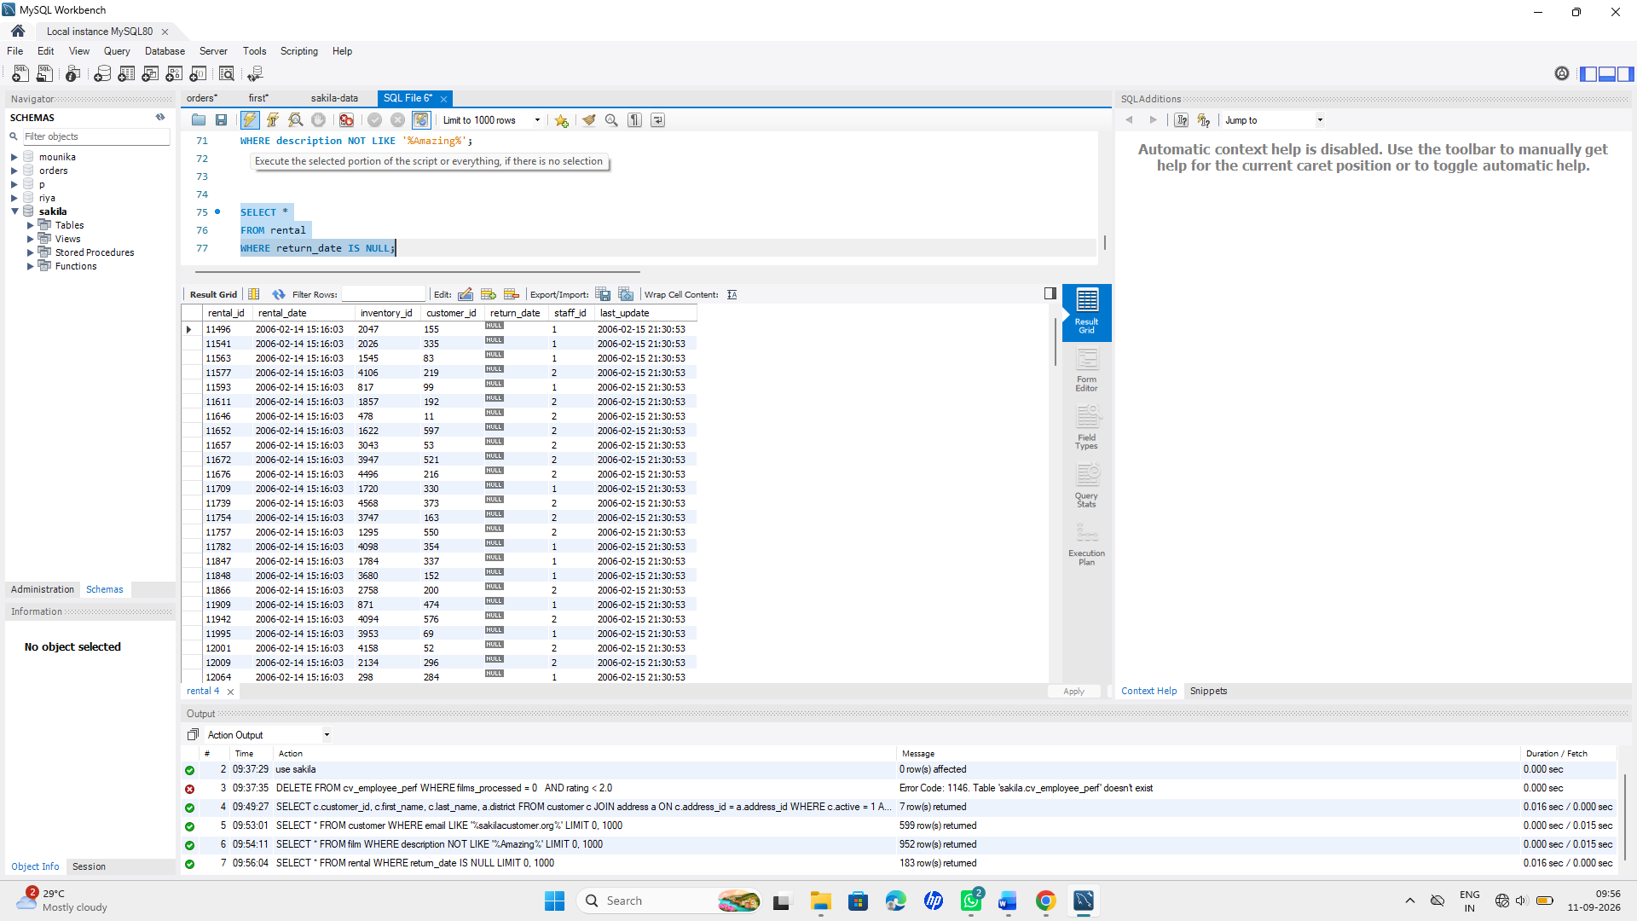

Q10. Operator Combination Challenge
Write a query to list film titles that are NOT in the 'Children', 'Music', or 'Travel' categories, have a rental_rate greater than 2.99, and a length NOT BETWEEN 60 and 90 minutes. (Use film, film_category, category.)
Query:
SELECT f.title
FROM film f
JOIN film_category fc
ON f.film_id = fc.film_id
JOIN category c
ON fc.category_id = c.category_id
WHERE c.name NOT IN ('Children', 'Music', 'Travel')
AND f.rental_rate > 2.99
AND f.length NOT BETWEEN 60 AND 90;

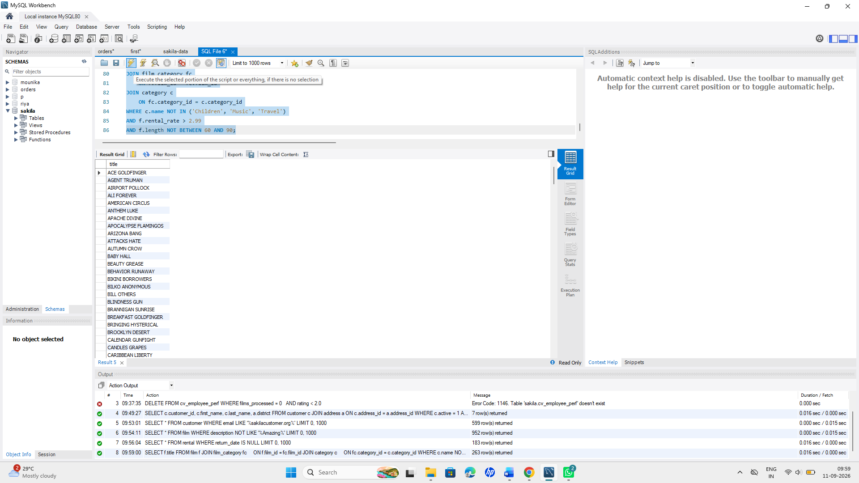

Section D — Relationship Analysis: All Joins
Operations wants a full 360° view

Q11. Inner Join — Core Report
Write a query to list film title, category name, and language name together for every film (only films that have all three linked) using INNER JOIN.

Query:
SELECT f.title AS film_title,
c.name AS category_name,
l.name AS language_name
FROM film f
INNER JOIN film_category fc
ON f.film_id = fc.film_id
INNER JOIN category c
ON fc.category_id = c.category_id
INNER JOIN language l
ON f.language_id = l.language_id;
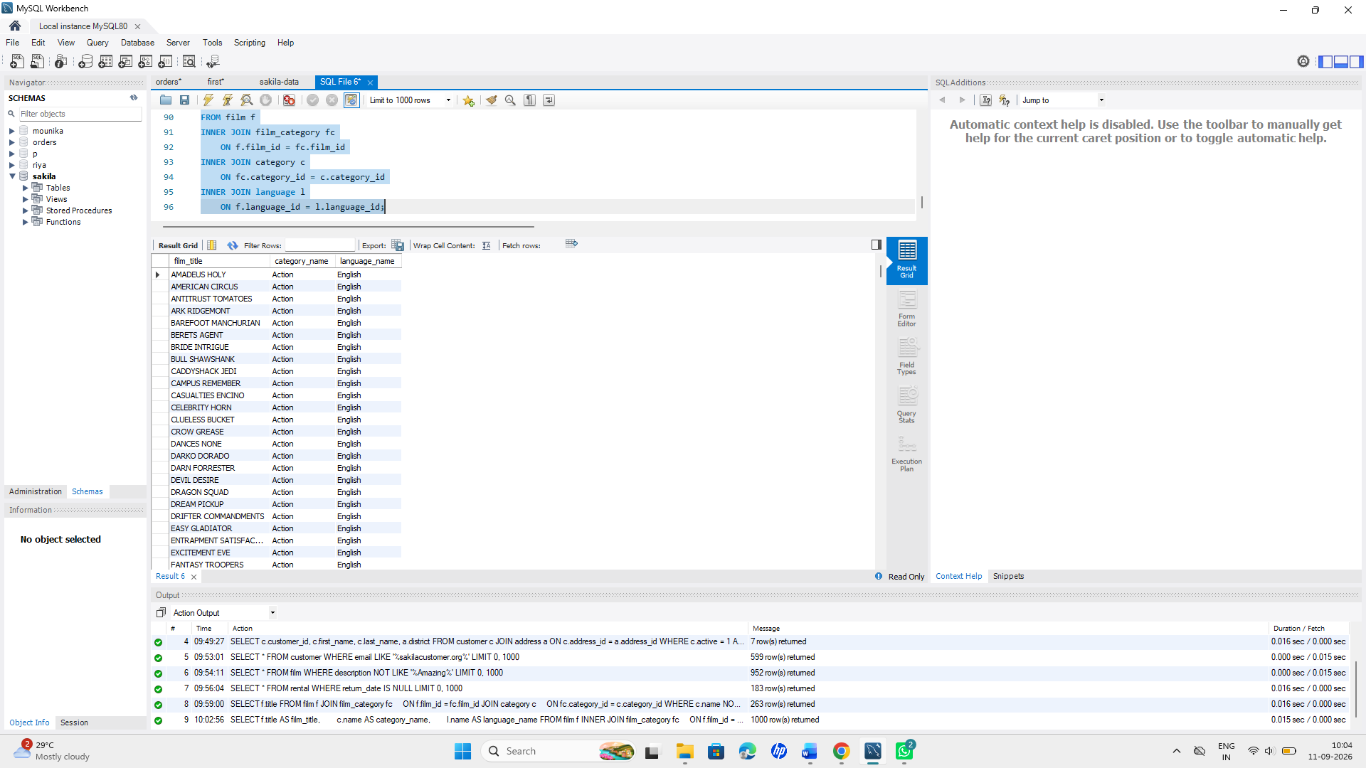
Q12. Left & Right Join — Gap Analysis
- Using LEFT JOIN, list every customer along with their rental count — customers with zero rentals must still appear with a count of 0.
Query:
SELECT
c.customer_id,
c.first_name,
c.last_name,
COUNT(r.rental_id) AS rental_count
FROM customer AS c
LEFT JOIN rental AS r
ON c.customer_id = r.customer_id
GROUP BY
c.customer_id,
c.first_name,
c.last_name;
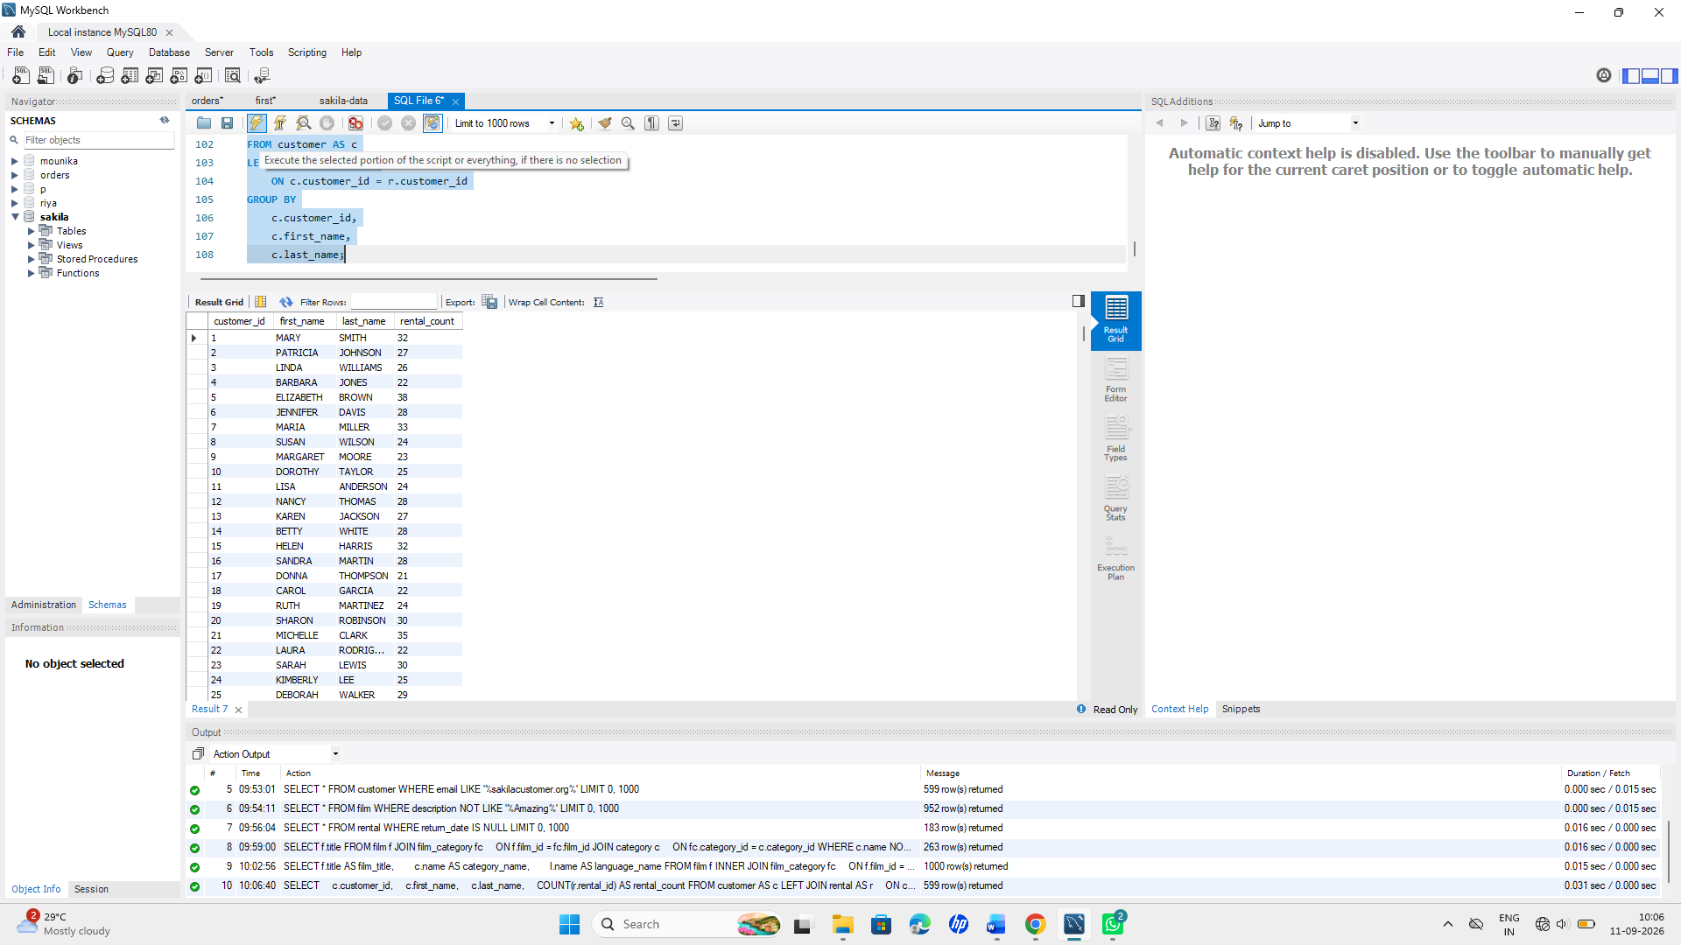

b)Using RIGHT JOIN (rewrite the same logic from the opposite table order), produce the same result — write it starting FROM rental ... RIGHT JOIN customer.
Query:
SELECT
c.customer_id,
c.first_name,
c.last_name,
COUNT(r.rental_id) AS rental_count
FROM rental AS r
RIGHT JOIN customer AS c
ON r.customer_id = c.customer_id
GROUP BY
c.customer_id,
c.first_name,
c.last_name;
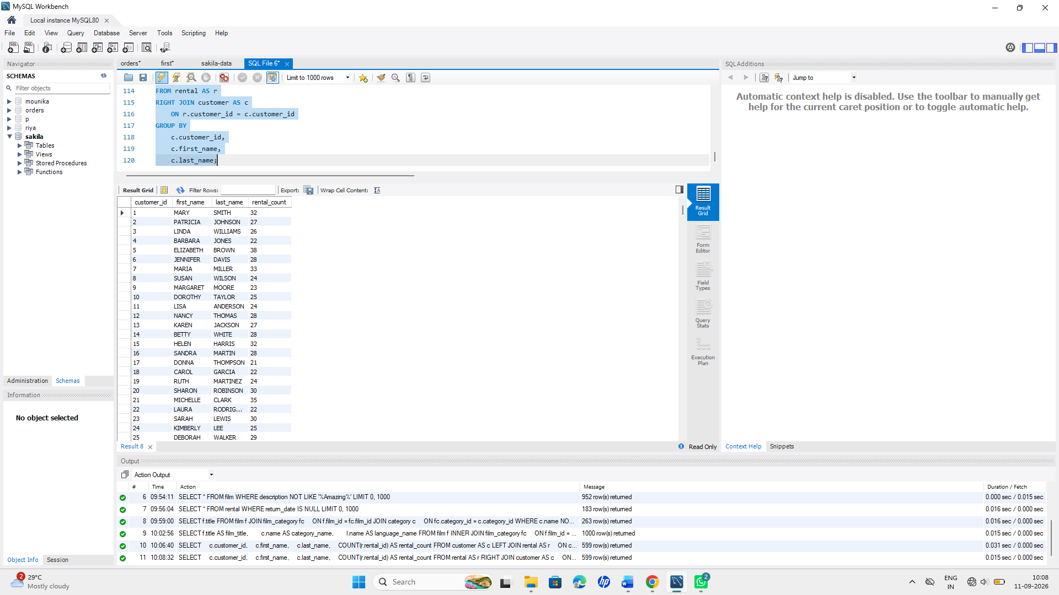

Q13. Full Outer Join Simulation
MySQL has no native FULL OUTER JOIN. CineVault wants a report of every actor and every film they may or may not be linked to, including actors with no films and films with no actors. Write a query using LEFT JOIN ... UNION ... RIGHT JOIN (or UNION of two LEFT JOINs) on actor, film_actor, and film to simulate this.

Query:
SELECT
a.actor_id,
CONCAT(a.first_name, ' ', a.last_name) AS actor_name,
f.film_id,
f.title
FROM actor AS a
LEFT JOIN film_actor AS fa
ON a.actor_id = fa.actor_id
LEFT JOIN film AS f
ON fa.film_id = f.film_id
UNION
SELECT
a.actor_id,
CONCAT(a.first_name, ' ', a.last_name) AS actor_name,
f.film_id,
f.title
FROM actor AS a
RIGHT JOIN film_actor AS fa
ON a.actor_id = fa.actor_id
RIGHT JOIN film AS f
ON fa.film_id = f.film_id;
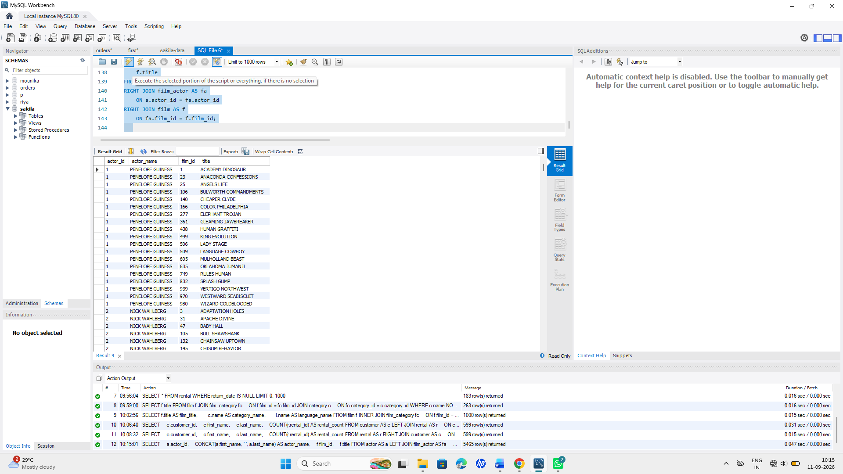
Q14. Self Join — Peer Comparison
HR wants to compare staff members who work at the same store. Write a self-join query on staff that lists pairs of staff members (s1.first_name, s2.first_name) working at the same store_id, excluding a staff member being paired with themselves.
Query:
SELECT
s1.first_name AS staff1_first_name,
s1.last_name AS staff1_last_name,
s2.first_name AS staff2_first_name,
s2.last_name AS staff2_last_name
FROM staff s1
INNER JOIN staff s2
ON s1.store_id = s2.store_id
AND s1.staff_id <> s2.staff_id;
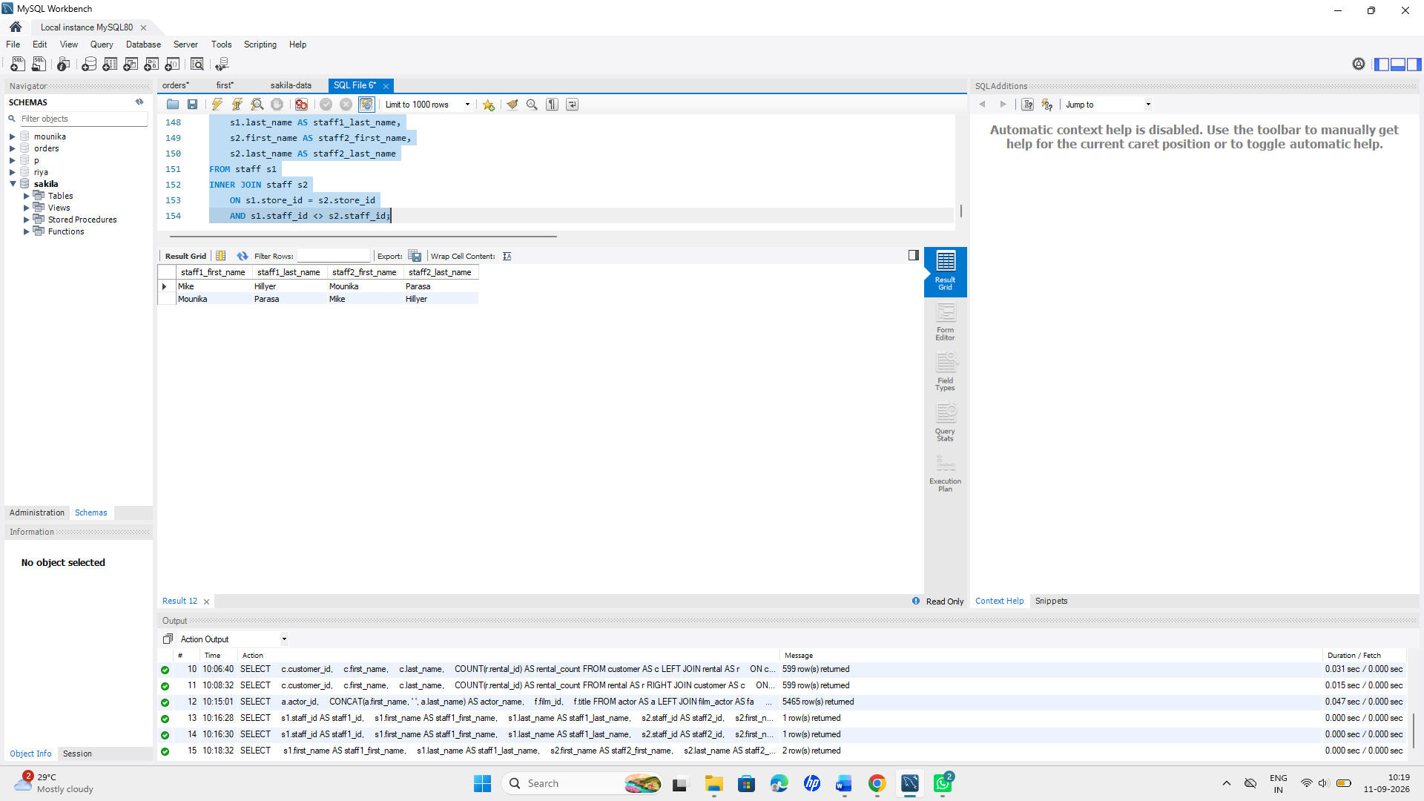

Q15. Cross Join — Scenario Planning
Marketing is planning a promotion matrix: every store combined with every film category, to decide which categories to promote at which store. Write a CROSS JOIN between store and category to generate this combination list. (Add a note on why CROSS JOIN should be used cautiously on large tables.)
QUERY:
SELECT
s.store_id,
c.category_id,
c.name AS category_name
FROM store s
CROSS JOIN category c;
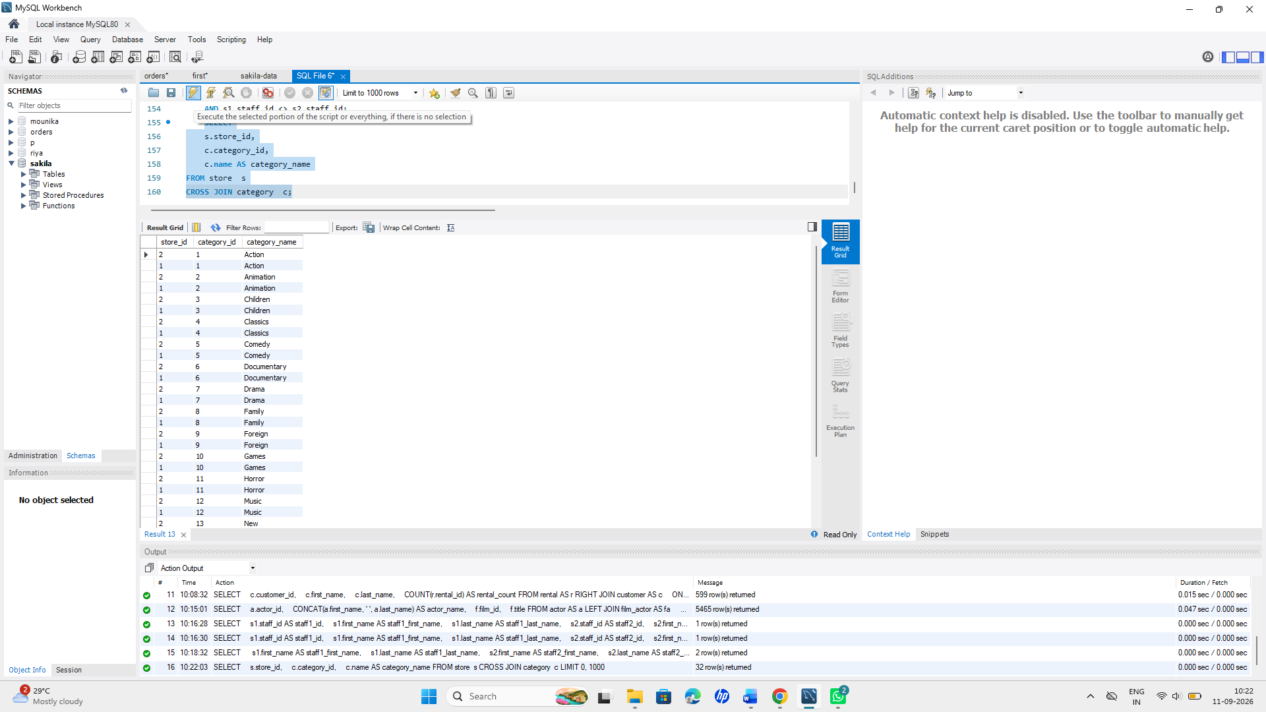
Section E — Aggregation, Grouping & Output-Based Questions
Q16. Revenue Report — Grouped
Finance wants monthly revenue trends.
- Write a query using GROUP BY to show total revenue (SUM(amount)) per staff_id from payment.
Query:

SELECT staff_id, SUM(amount) AS total_revenue
FROM payment
GROUP BY staff_id;

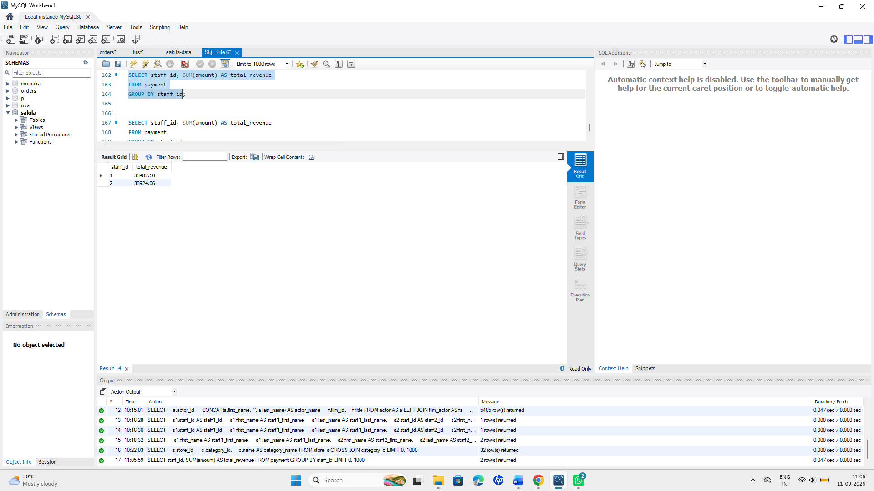
b)Extend it with HAVING to show only staff whose total revenue exceeds 15000.

Query::
SELECT staff_id, SUM(amount) AS total_revenue
FROM payment
GROUP BY staff_id
HAVING SUM(amount) > 15000;
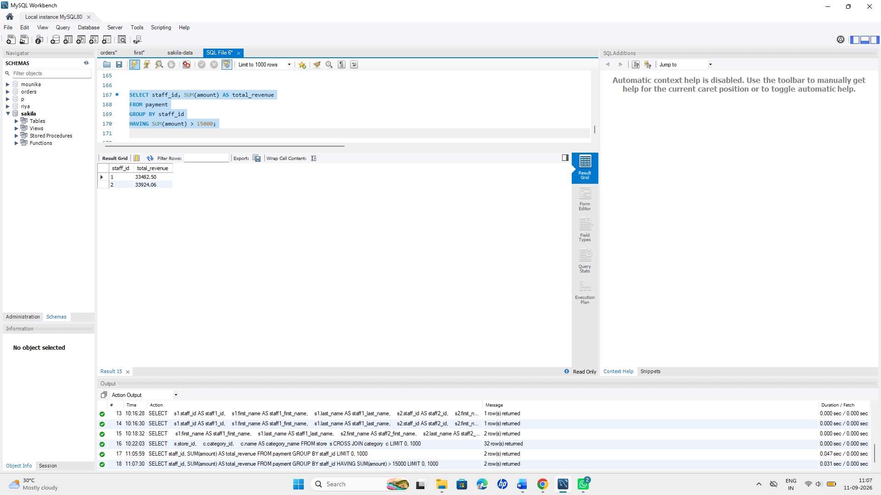

Now write a version without grouping — a single query showing the overall company-wide total revenue and the single highest individual payment amount, side by side (use aggregate functions without GROUP BY).
Query:

SELECT SUM(amount) AS total_company_revenue,
MAX(amount) AS highest_payment
FROM payment;
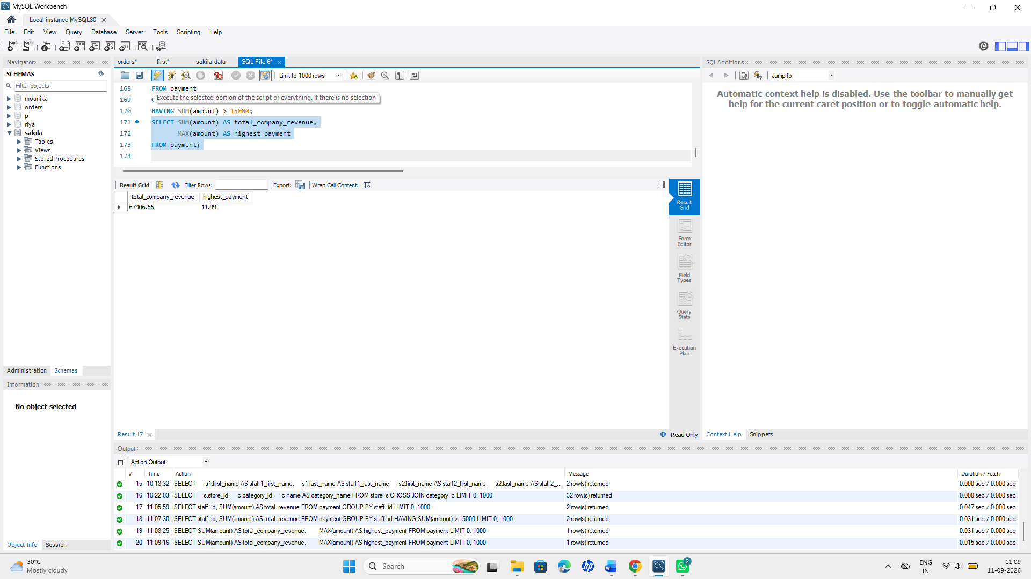

Q17. Output-Based Question — Reverse Engineer the Query
You are shown the following result set from a query run on sakila:
category_name | total_films | avg_rental_rate
Action | 64 | 3.28
Sports | 74 | 3.13
Sci-Fi | 61 | 2.99
The result is sorted by total_films descending, and only shows categories with more than 60 films.
Write the exact MySQL query that would produce this output. (Tables: film, film_category, category.)
Query:
SELECT
c.name AS category_name,
COUNT(f.film_id) AS total_films,
ROUND(AVG(f.rental_rate), 2) AS avg_rental_rate
FROM category AS c
INNER JOIN film_category AS fc
ON c.category_id = fc.category_id
INNER JOIN film AS f
ON fc.film_id = f.film_id
GROUP BY c.category_id, c.name
HAVING COUNT(f.film_id) > 60
ORDER BY total_films DESC;
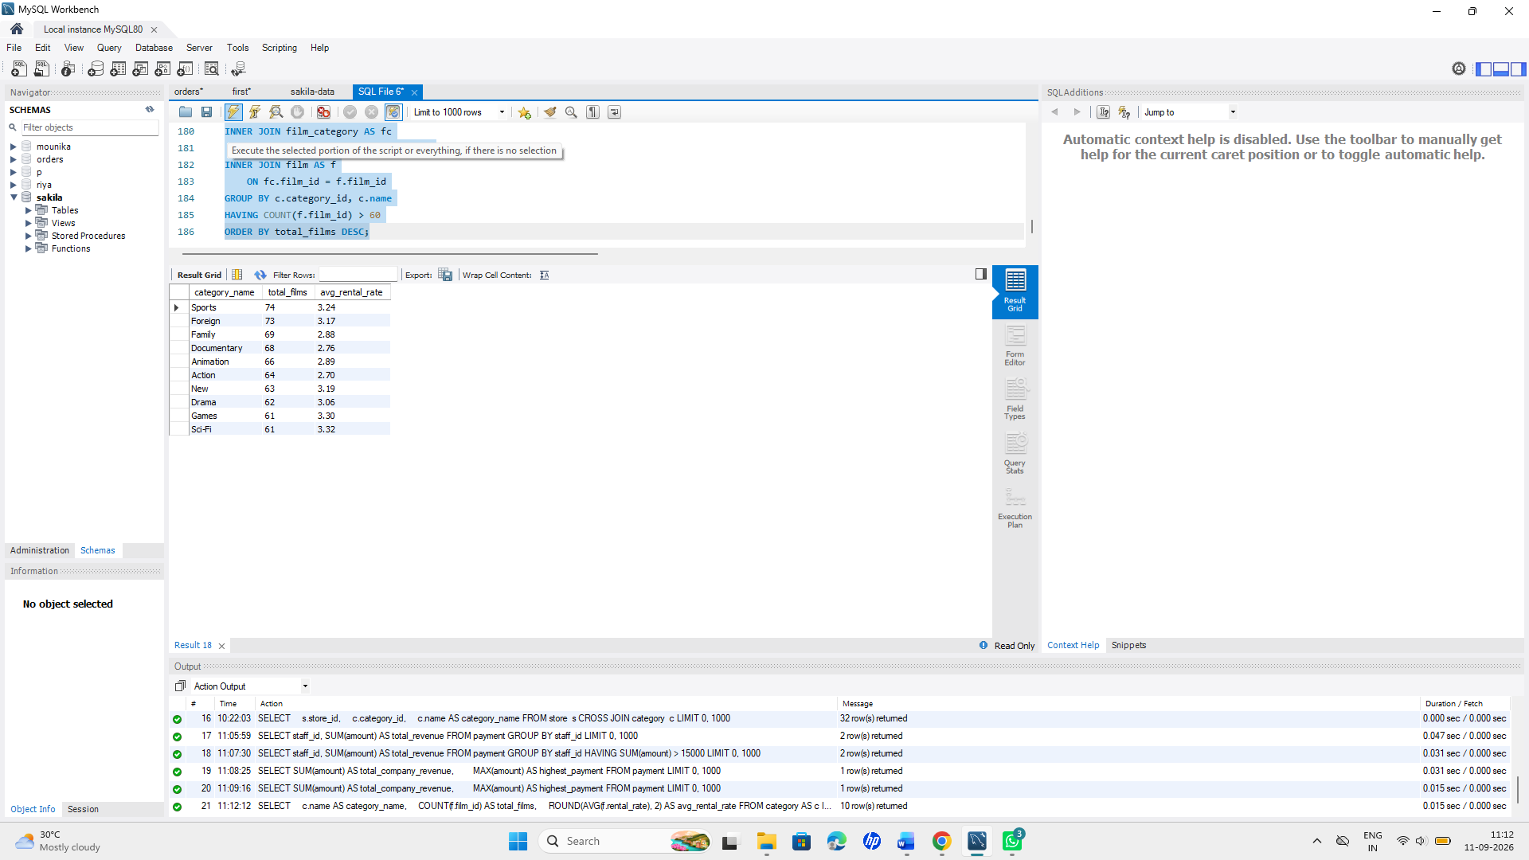
Q18. Output-Based Question — Rank the Customers
You are shown this result:
customer_id | first_name | total_spent | spend_rank
137 | Karl | 221.55 | 1
526 | Eleanor | 216.54 | 2
148 | Clara | 195.58 | 3
The spend_rank column ranks customers by their total payments, highest first, with no gaps in ranking even if totals tie.
Write the query — you must use a window function (RANK() or DENSE_RANK()), not a subquery-only approach, to generate spend_rank.
Query:
SELECT
c.customer_id,
c.first_name,
SUM(p.amount) AS total_spent,
DENSE_RANK() OVER (
ORDER BY SUM(p.amount) DESC
) AS spend_rank
FROM customer AS c
INNER JOIN payment AS p
ON c.customer_id = p.customer_id
GROUP BY
c.customer_id,
c.first_name
ORDER BY spend_rank;
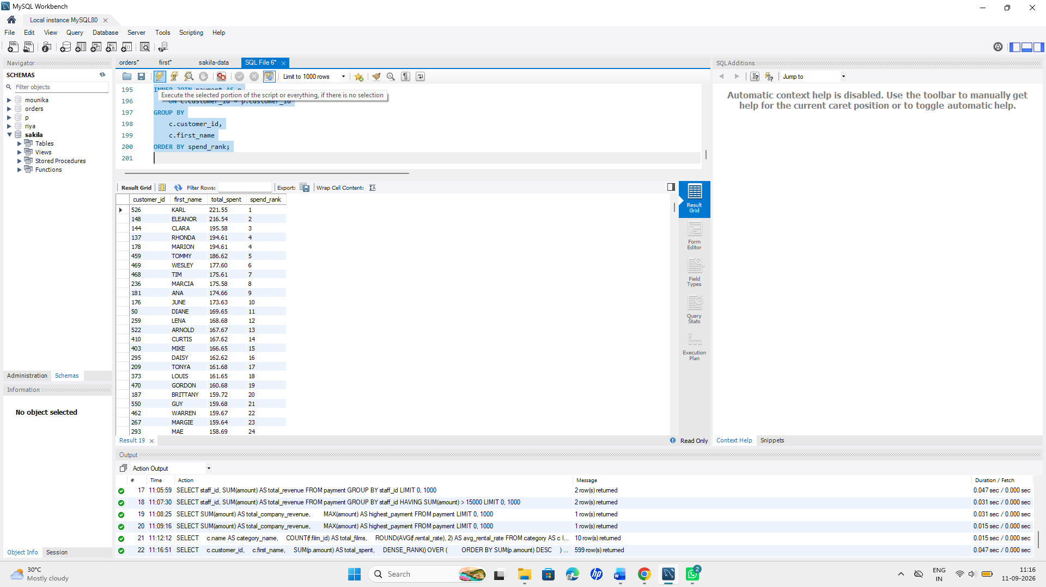
Section F — Advanced Analytics: Subqueries & Window Functions
Q19. Subqueries — Nested & Correlated
- Nested subquery: Write a query to find all films whose rental_rate is higher than the average rental rate of their own category (hint: correlated subquery referencing the outer film's category_id).
Query:
SELECT
f.film_id,
f.title,
f.rental_rate
FROM film AS f
INNER JOIN film_category AS fc
ON f.film_id = fc.film_id
WHERE f.rental_rate >
(
SELECT AVG(f2.rental_rate)
FROM film AS f2
INNER JOIN film_category AS fc2
ON f2.film_id = fc2.film_id
WHERE fc2.category_id = fc.category_id
);
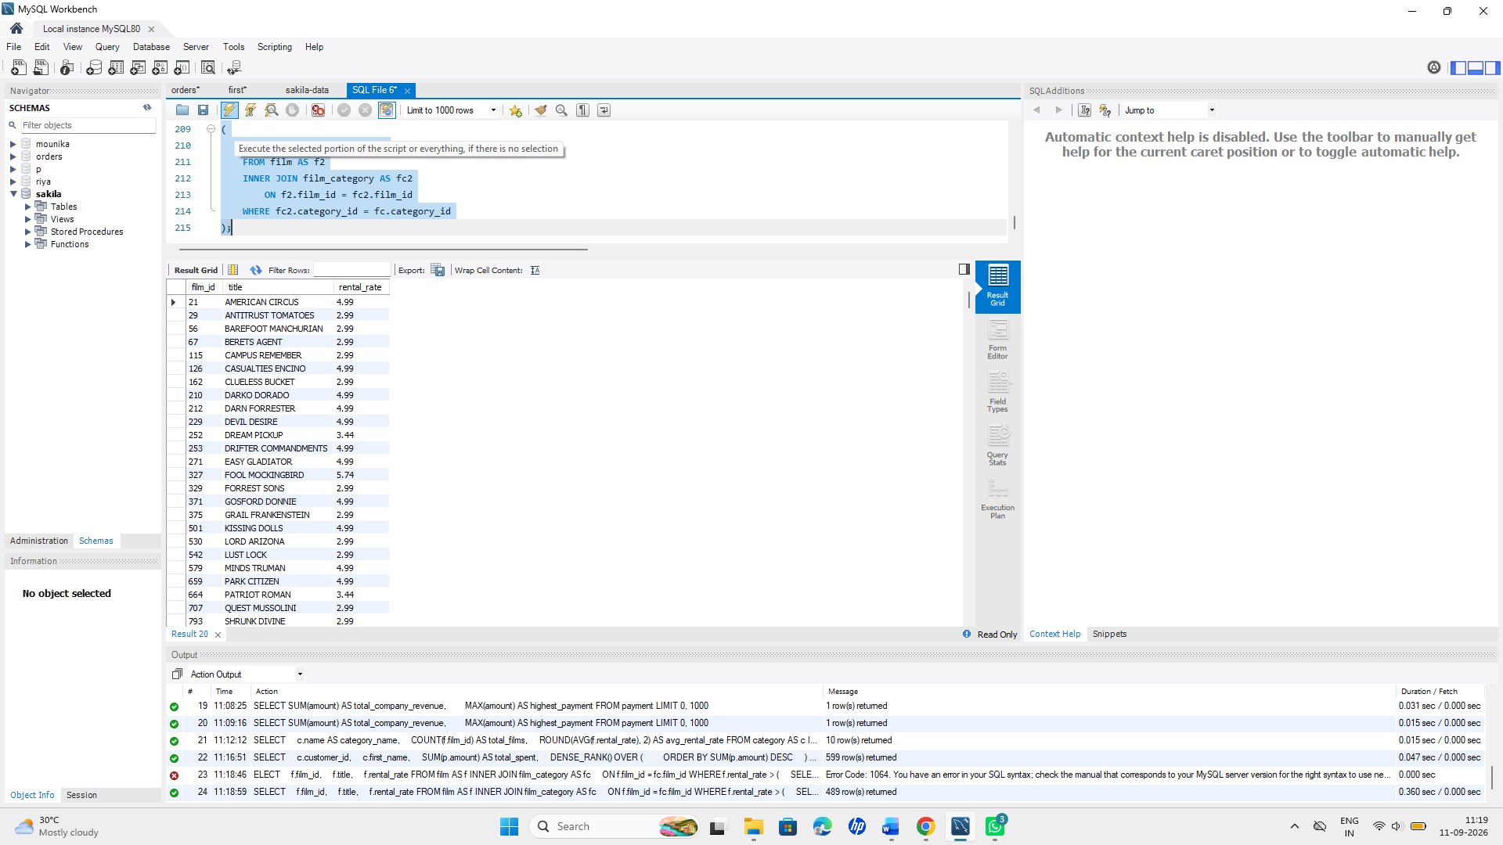

- EXISTS subquery: Write a query to list customers who have never made a payment (use NOT EXISTS).
Query:
SELECT c.customer_id,
c.first_name,
c.last_name
FROM customer c
WHERE NOT EXISTS (
SELECT 1
FROM payment p
WHERE p.customer_id = c.customer_id
);
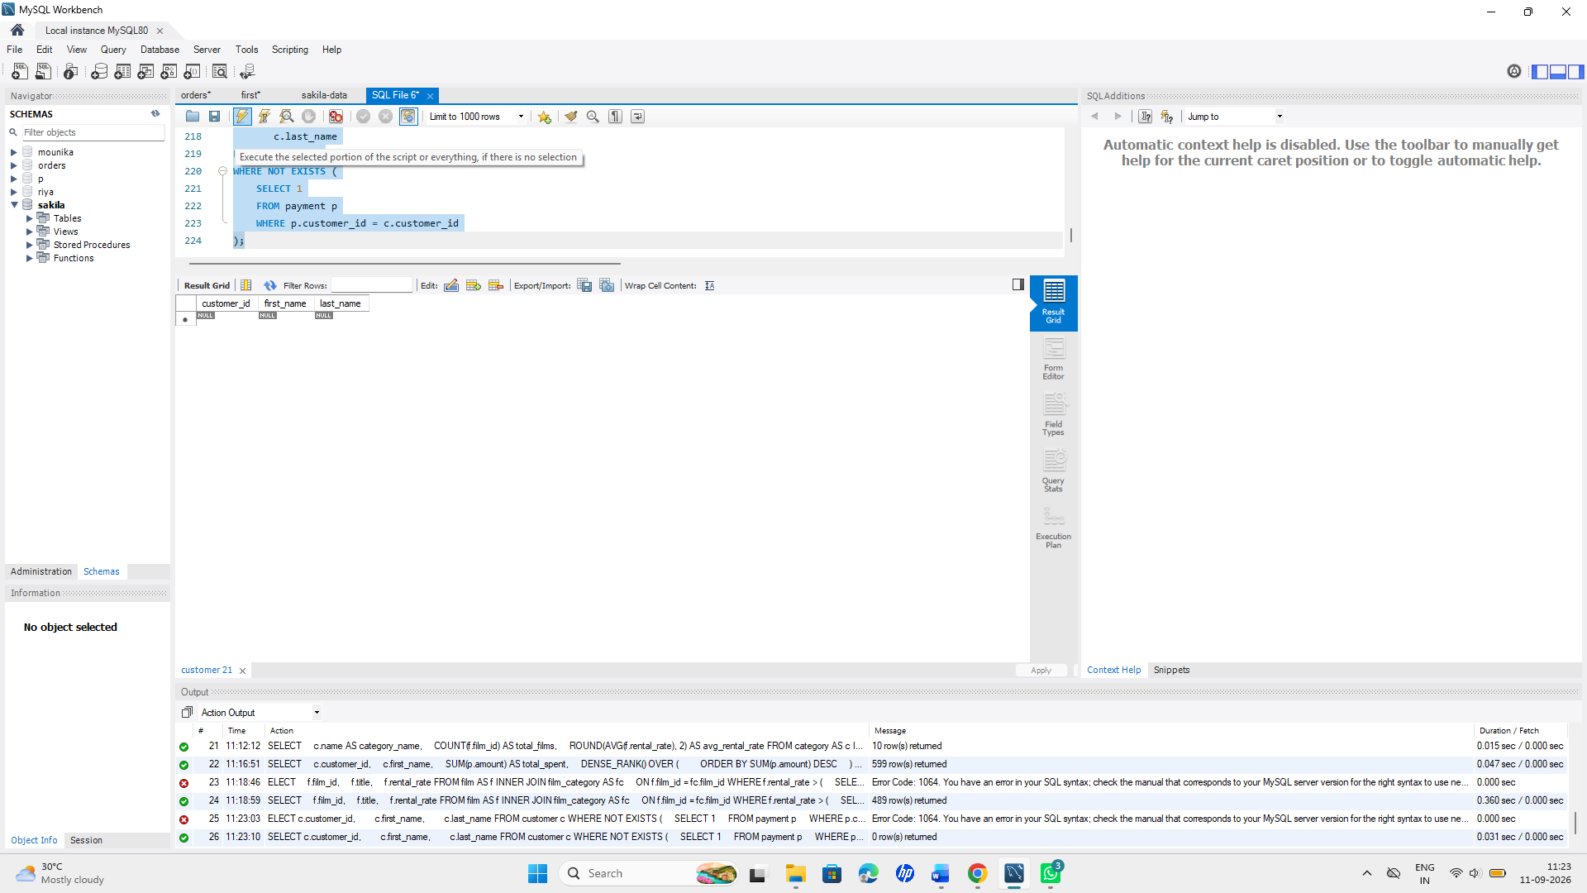

- Briefly explain (1–2 lines) the performance difference between using IN with a subquery versus EXISTS when the subquery returns a large number of rows.
** EXISTS can be more efficient for large subquery results because it checks whether a match exists and can stop early, instead of processing all returned values.
Q20. Window Functions — Store-Level Analysis
Operations wants to identify, for each store, the top 3 films by total rental count (a “Top 3 per Store” leaderboard).
- Write a query using ROW_NUMBER() (or RANK()) partitioned by store_id and ordered by rental count descending, then filter to only the top 3 per store (use a CTE or subquery, since you cannot filter directly on a window function in the same SELECT).
Query:
WITH film_rentals AS (
SELECT i.store_id,
f.film_id,
f.title,
COUNT(r.rental_id) AS rental_count,
ROW_NUMBER() OVER (
PARTITION BY i.store_id
ORDER BY COUNT(r.rental_id) DESC
) AS rn
FROM inventory i
JOIN film f
ON i.film_id = f.film_id
JOIN rental r
ON i.inventory_id = r.inventory_id
GROUP BY i.store_id, f.film_id, f.title
)
SELECT store_id, film_id, title, rental_count
FROM film_rentals
WHERE rn <= 3
ORDER BY store_id, rental_count DESC;
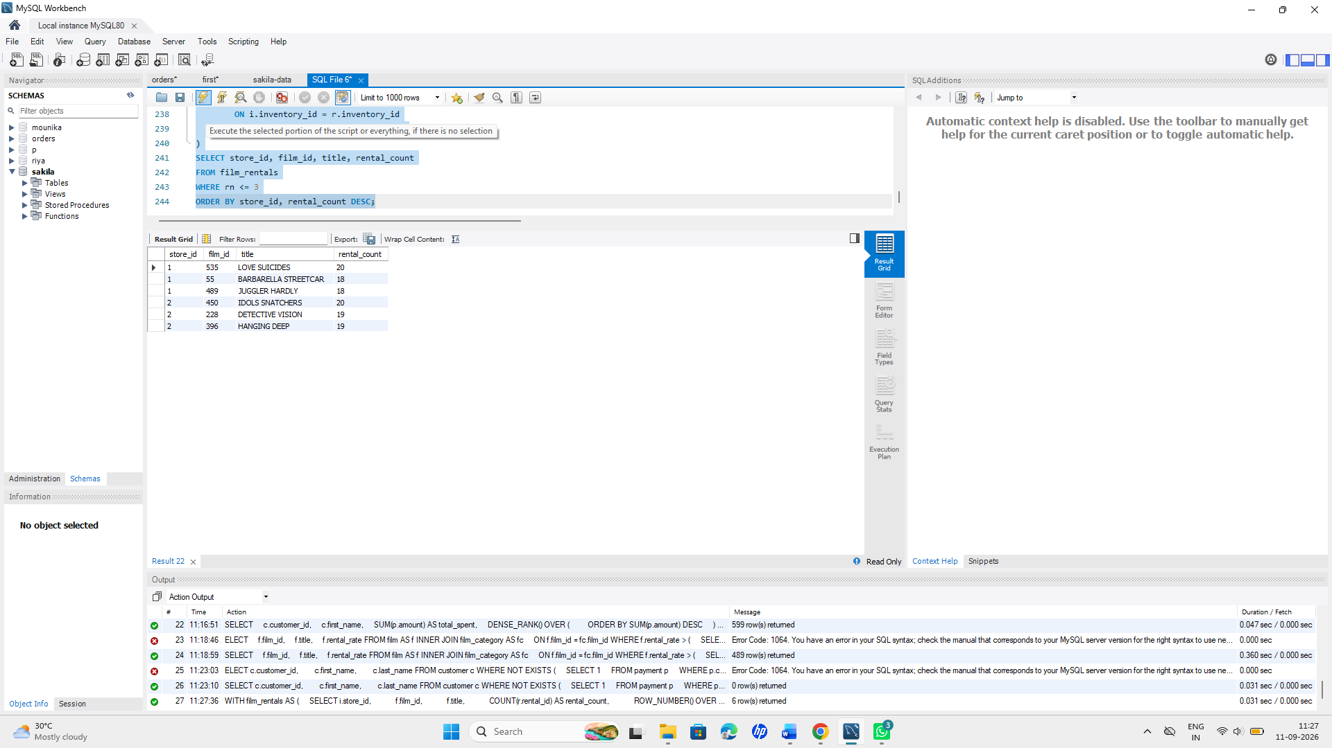
b) In one line, explain the difference between ROW_NUMBER(), RANK(), and DENSE_RANK() if two films in the same store had the exact same rental count.
ROW_NUMBER() gives unique ranks,RANK() gives equal ranks with gaps,while DENSE_RANK() gives equal ranks without gaps.

Bonus (Optional — extra credit)
Write a single query combining a CTE, a JOIN, and a window function to show each customer's rental history along with a running total (SUM() OVER) of their spending, ordered by payment date.
Query:
WITH rental_data AS (
SELECT
c.customer_id,
c.first_name,
r.rental_date,
p.amount
FROM customer c
JOIN rental r
ON c.customer_id = r.customer_id
JOIN payment p
ON r.rental_id = p.rental_id
)
SELECT
customer_id,
first_name,
rental_date,
amount,
SUM(amount) OVER (
PARTITION BY customer_id
ORDER BY rental_date
) AS running_total
FROM rental_data
ORDER BY customer_id, rental_date;
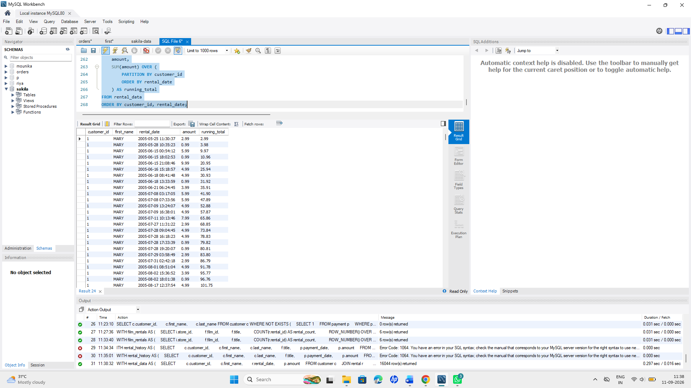
--------------------------------------------- END --------------------------------------------
SUBMITTED BY : MOUNIKA PARASA
BATCH-2(2028)

